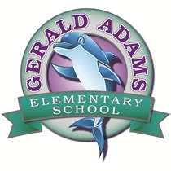

SAC Agenda 10/10/2018

5:30 pm Media Center

1. Meeting Call to Order
2. Adoption of Agenda
3. Introduction & Welcome
4. New Business
5. Construction Update

⦁ Possible parent tour scheduled for December

⦁Move in date

1. Internet Safety Presentation by Tammy Orcutt, Counselor at GAE
2. SIP Overview and Approval
3. Early Release Days/Honor Roll Celebration times
4. Open Agenda
5. Next Meeting Confirmation / Adjournment

**Chairman Notes:**

* Upcoming SAC meeting dates: Next meeting tentatively scheduled for November 14th @ 8:00 am.

**At Gerald Adams Elementary, we are committed to working to collaboratively provide a quality learning environment in which ALL children can learn and develop to their maximum potential.**